4th Week Assignment
Subject-Computer
Class-VIII
Kindly.read and write the answer-
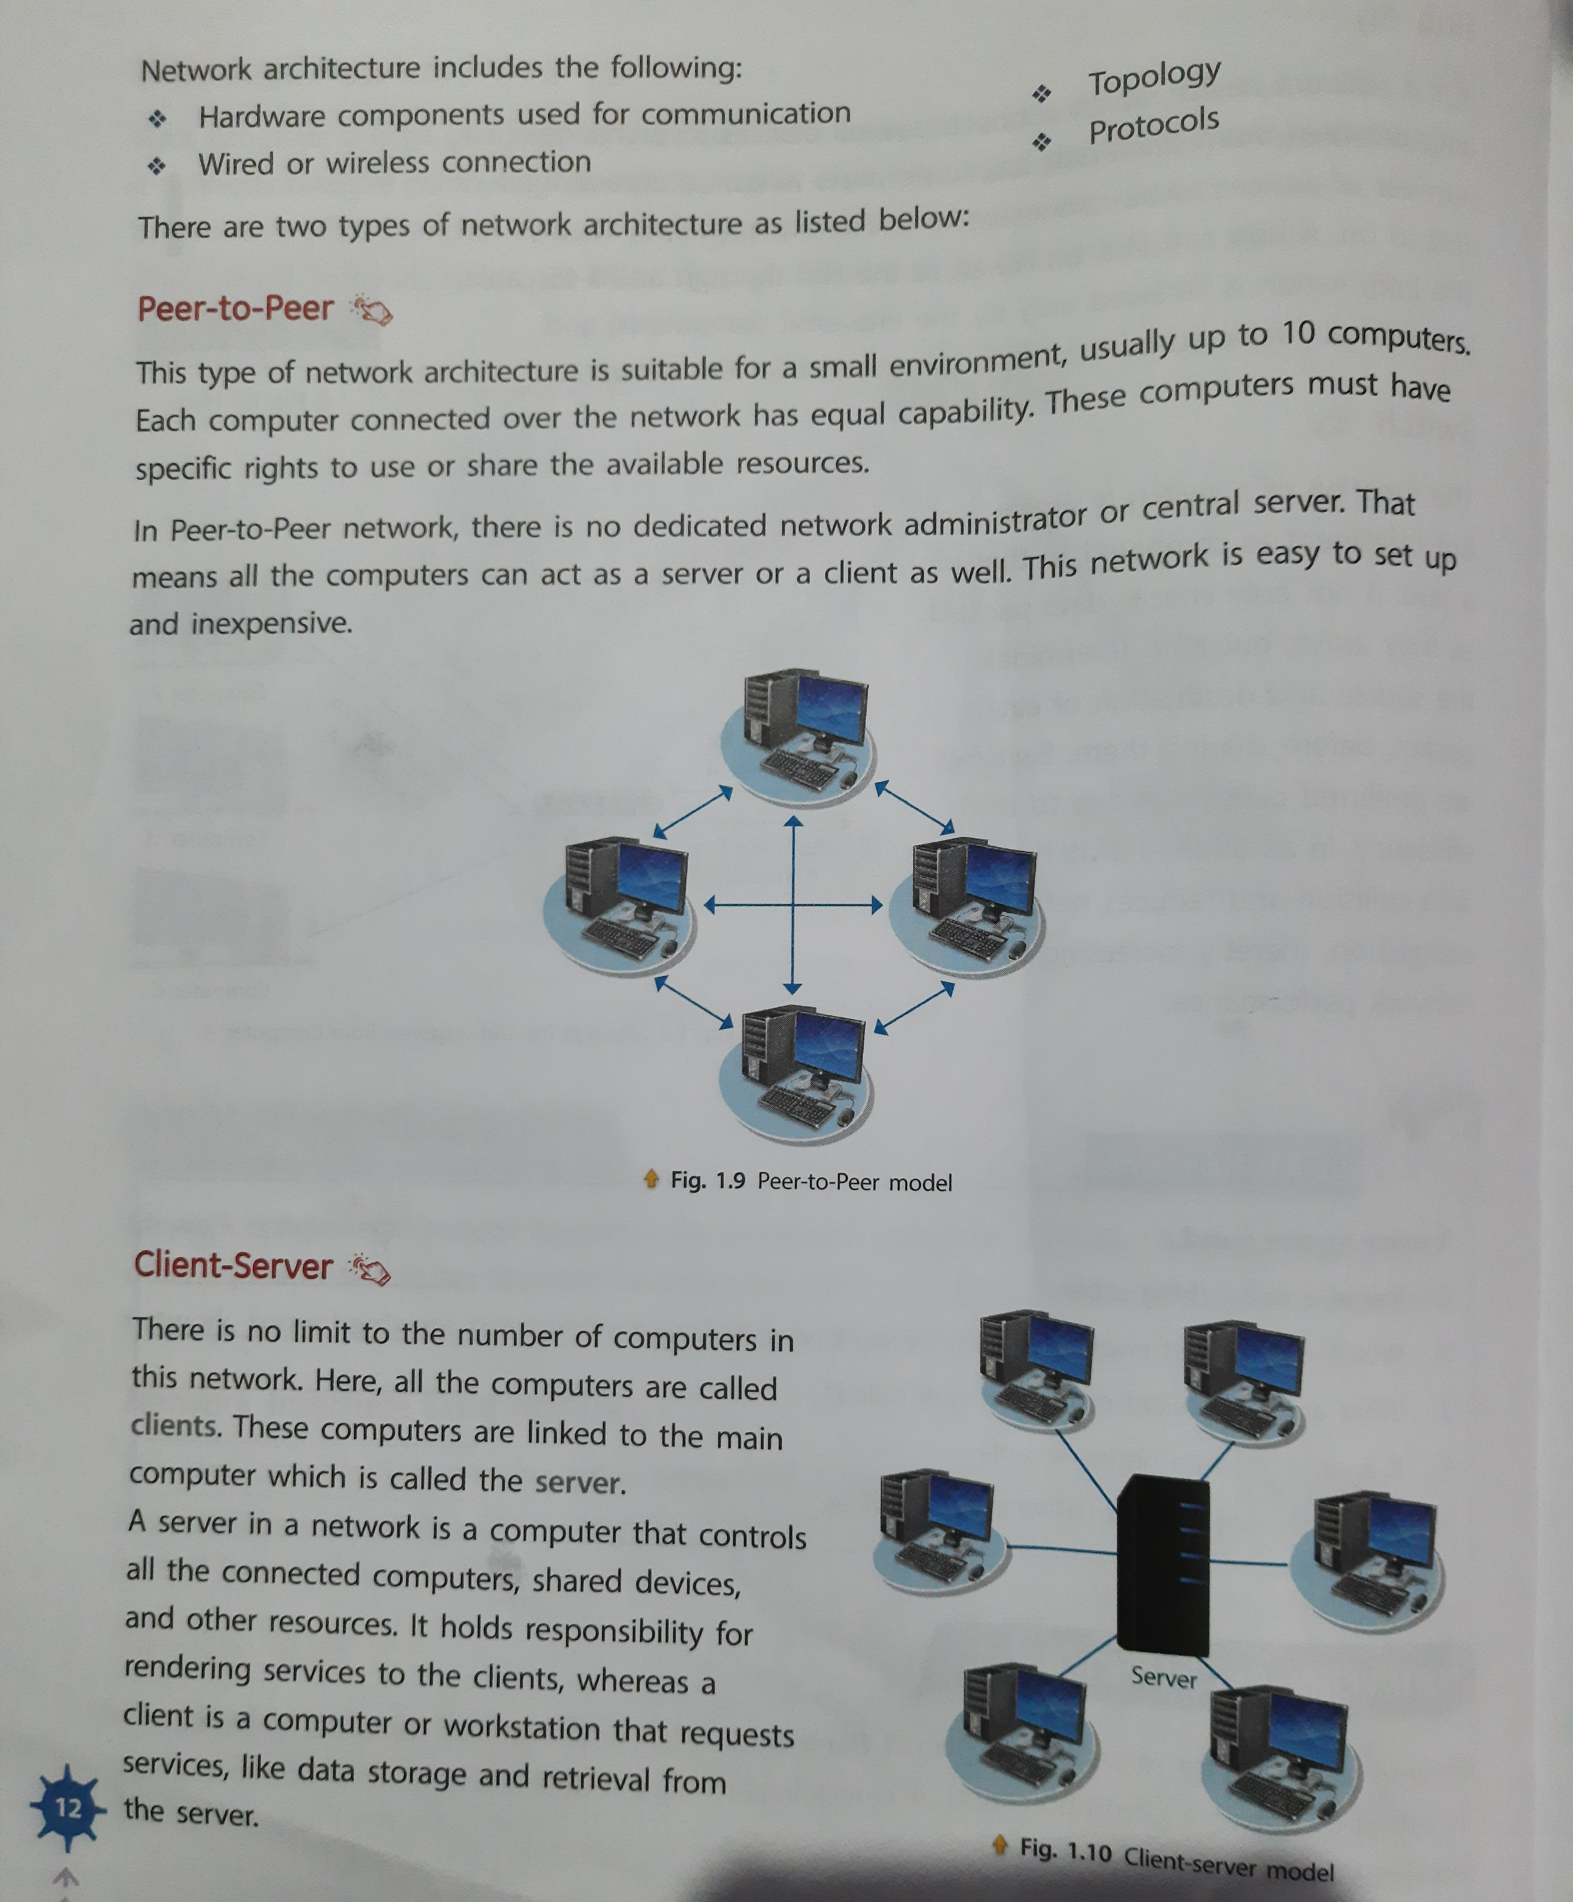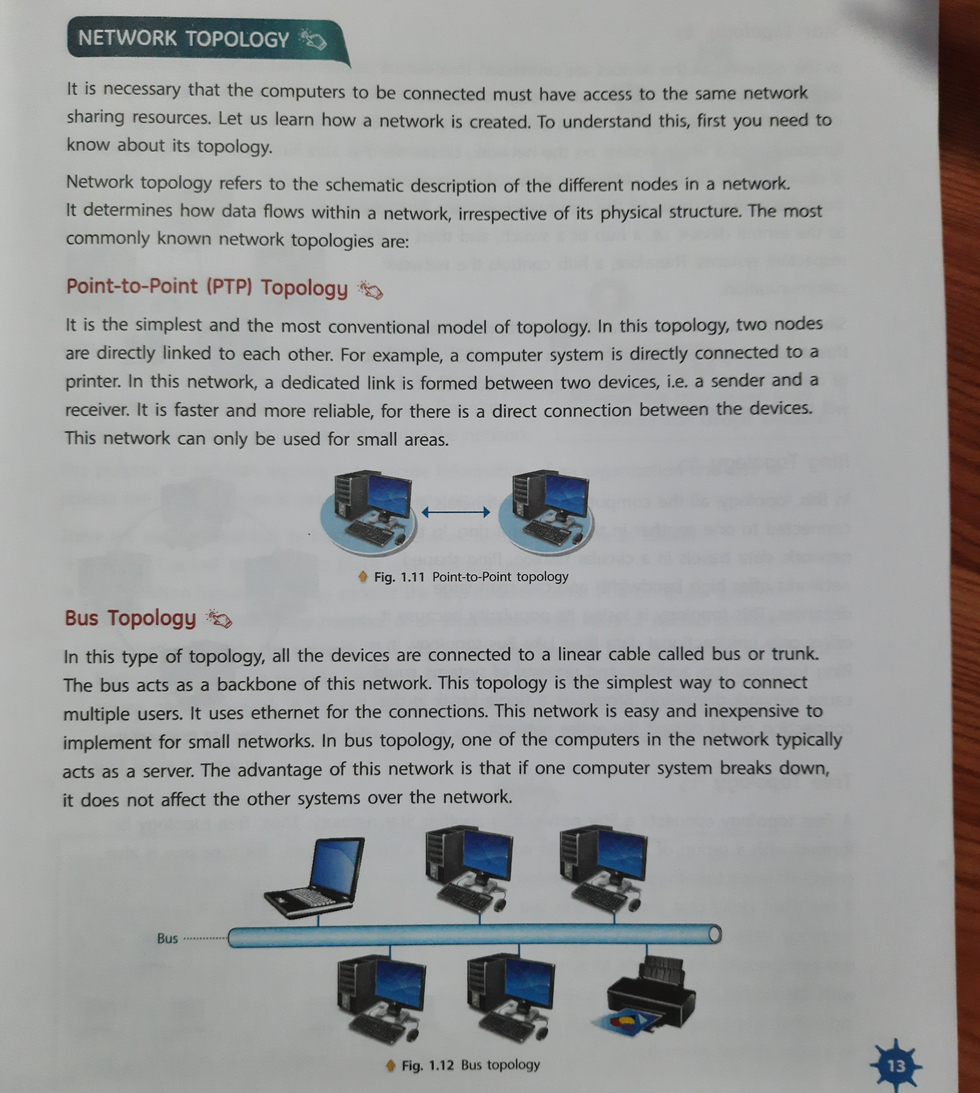

There are two types of network architecture-(a) peer to peer (b) Client-Server
In peer to peer architecture two or more computers are directly connected to each other.There is no central device.This is a type of non dedicated network .In client server architecture there is a central device called
Servers and computers are connected to this servers.Those computers which are connected to servers are called
Nodes or clients..Topology is the physical arrangement of computers in a network.Bus topology got it name
Bus as its structure was just like a bus.In bus topology there runs a single wire in whicj computers are connected.

Answer the following question-

- Write and explain peer to peer architecture with diagram.
- Write and explain client server architecture with diagram.
- What is topology ?
- What is point to point topology ?
- What is bus topology ?

