Assignment – 12
Session : 2020 -21
Std – 01
Subject – Maths Date – 06 -07- 2020

LESSON- 05 Shapes And Patterns
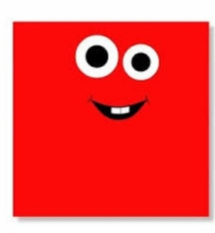
Plane Shapes
i. Square
- Sides – 04
- Corners – 04

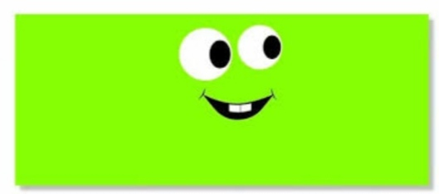
ii. Rectangle
- Sides – 04
- Corners – 04
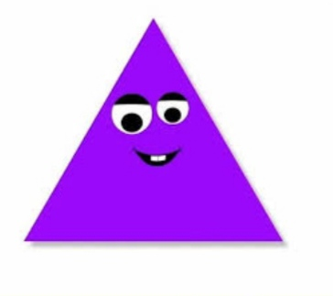
iii. Triangle
- Sides – 03
- Corners – 03
iv. Circle
- It has no sides and corners.
- It is round in shape.

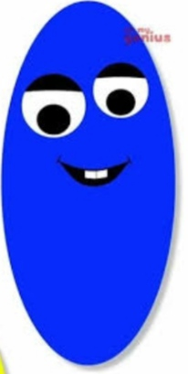
v. Oval
- It has no sides and corners.
- It looks like an egg .

- Match the shapes to an object with the similar shape .
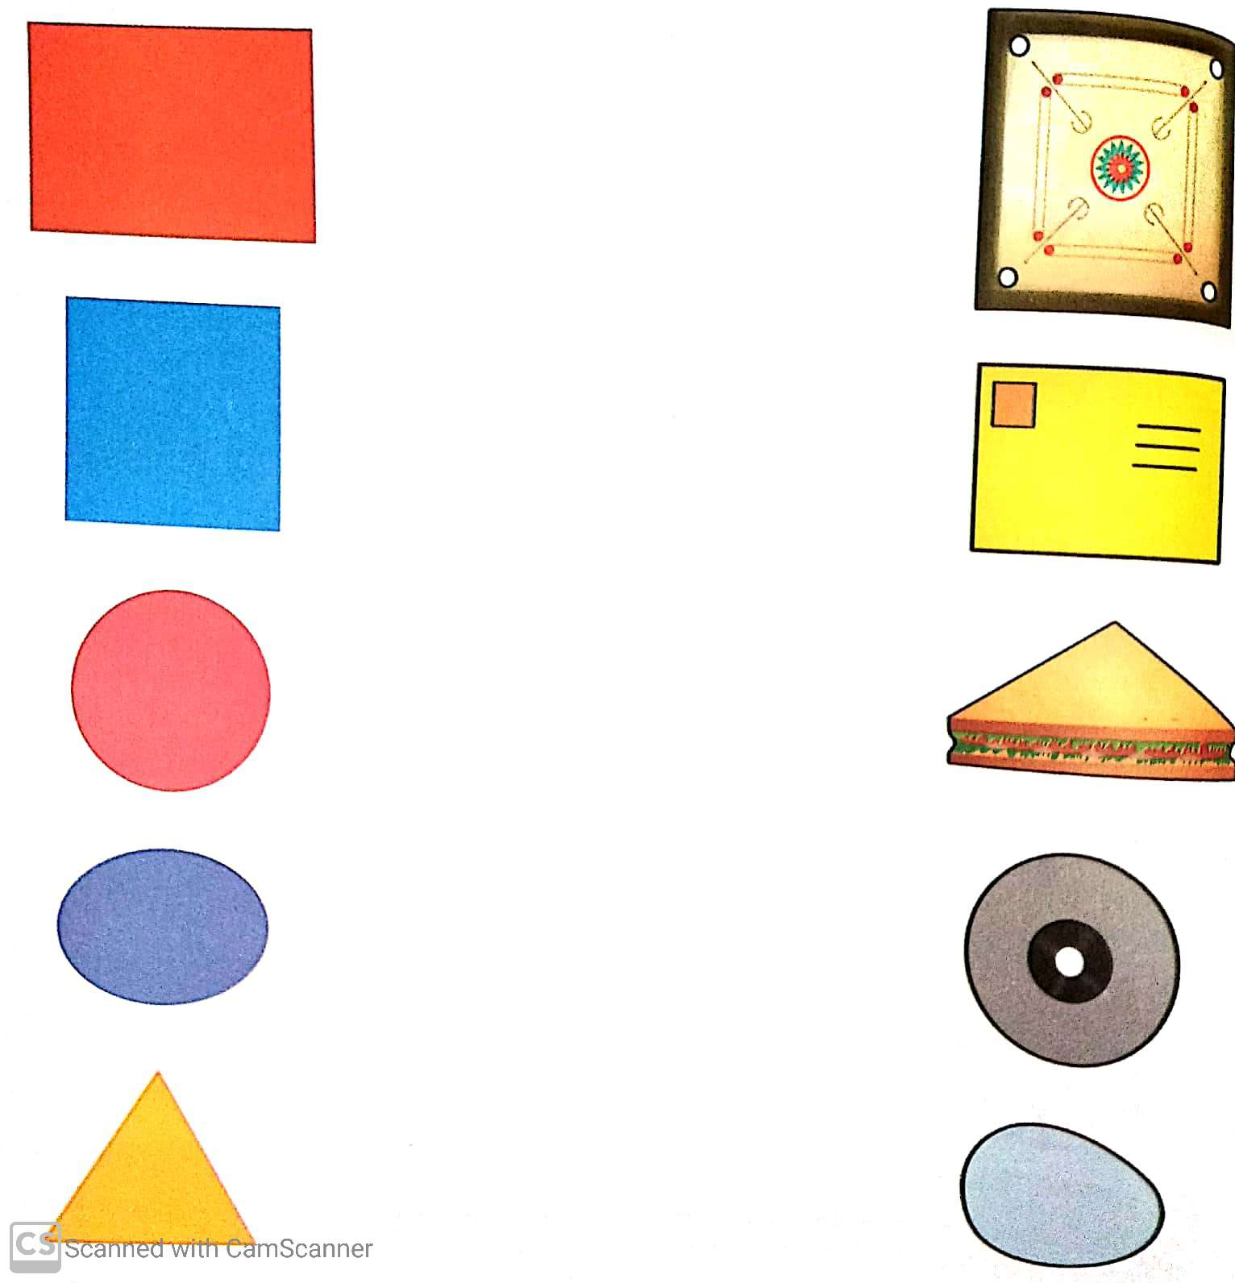
Note: Do the given assignment in your Maths note book.
Do page no.54 and 56 in the Maths text book.

