Assignment 12 (2020-2021)
Class – Prep Sub. – Maths

Q.1.
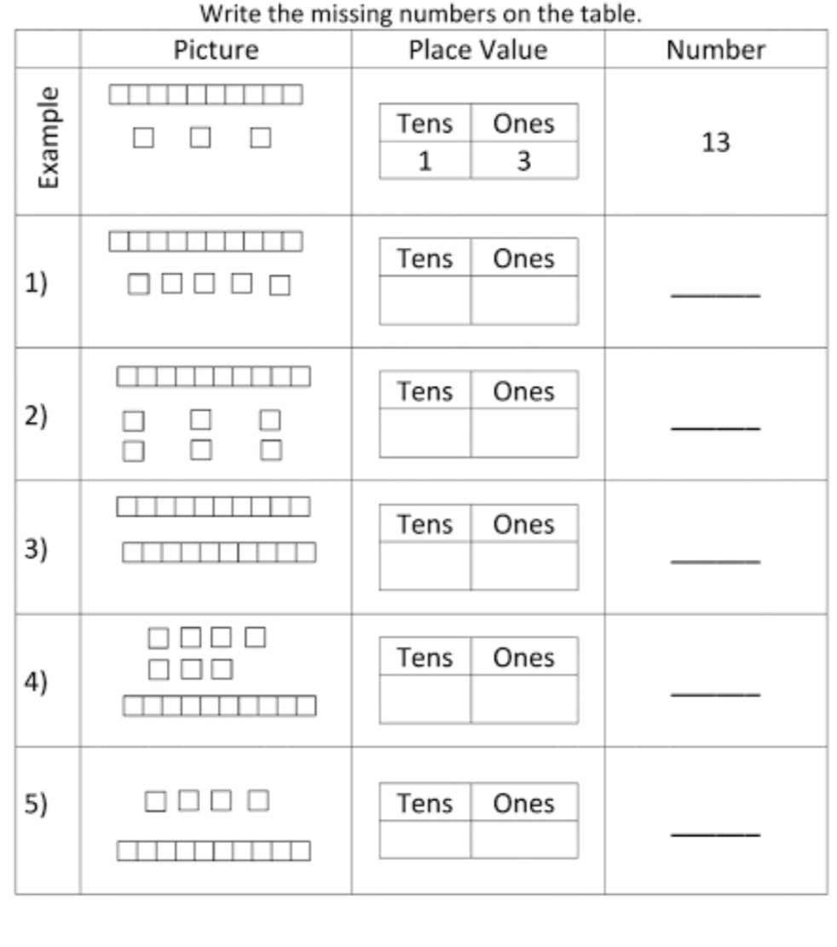

Q.2.
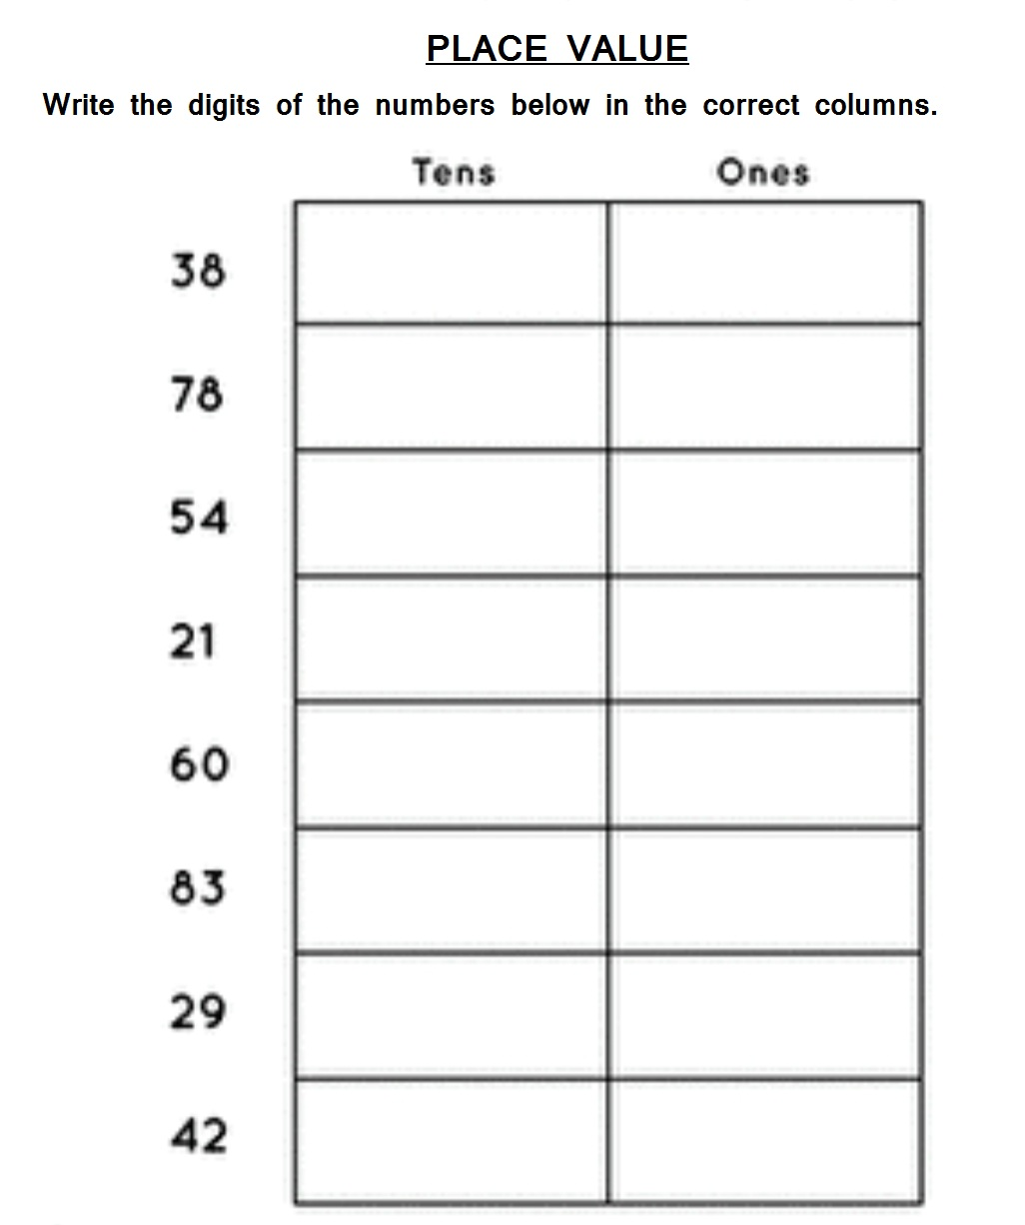

Q.3.
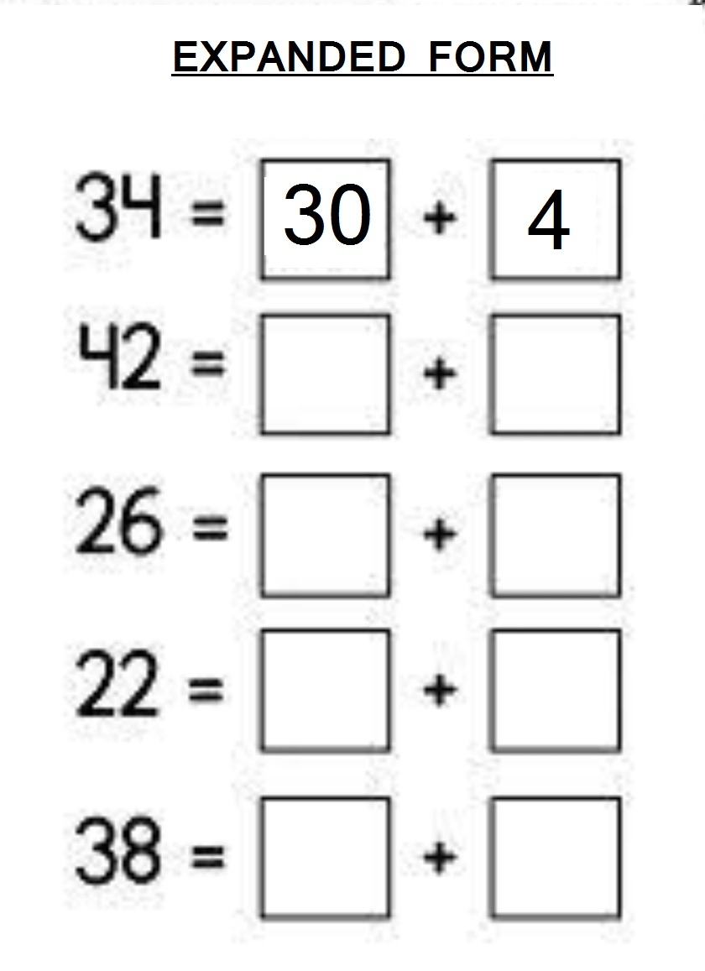

Q.4.
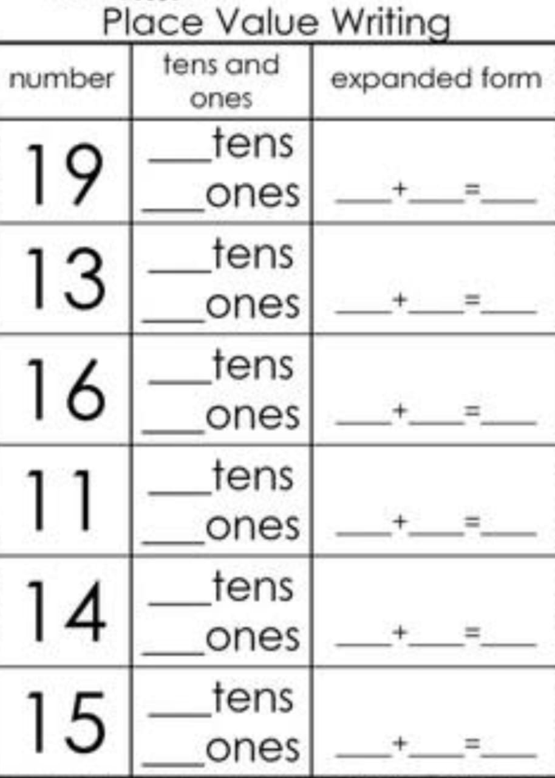

Q.5.
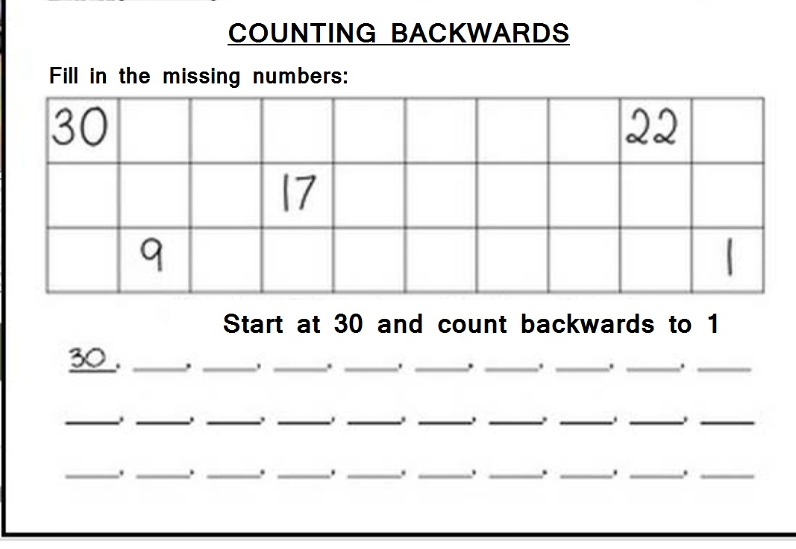

Q.6.
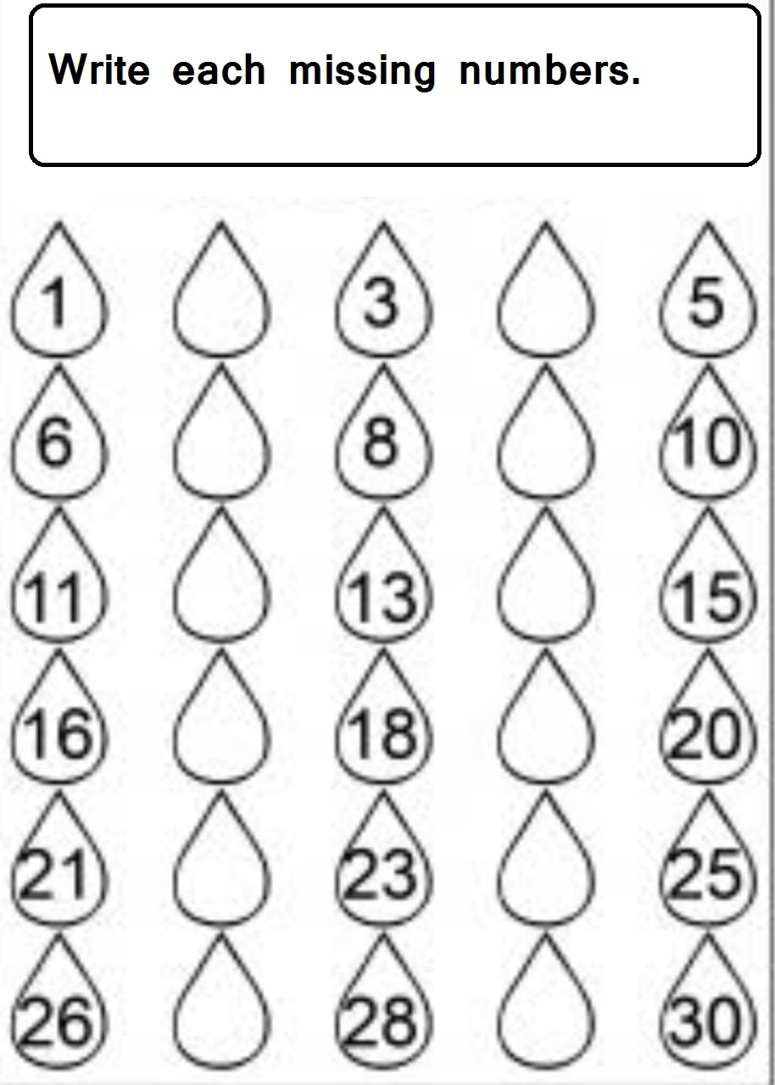

Answer Key
1.
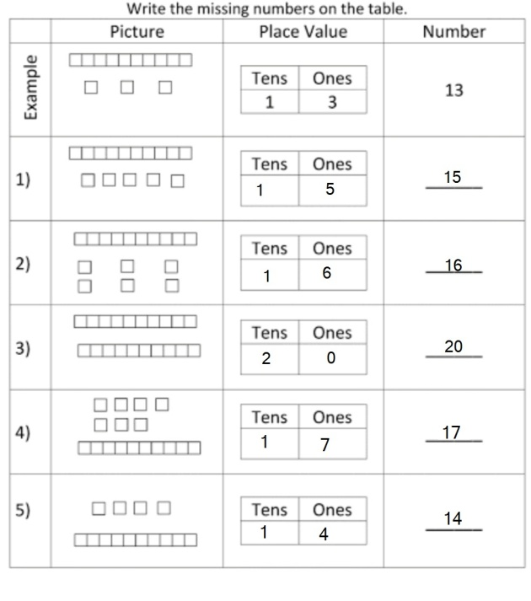
2.
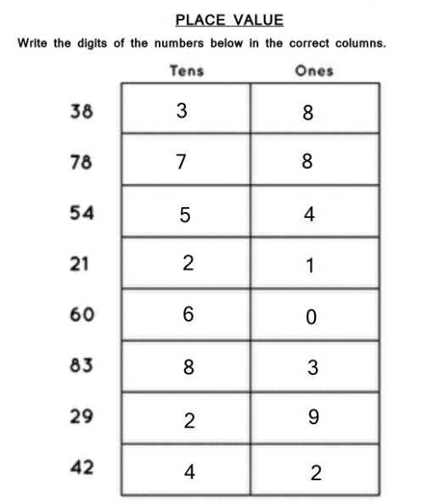

3.
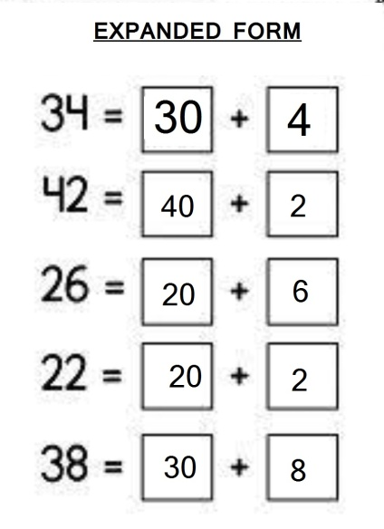
4.
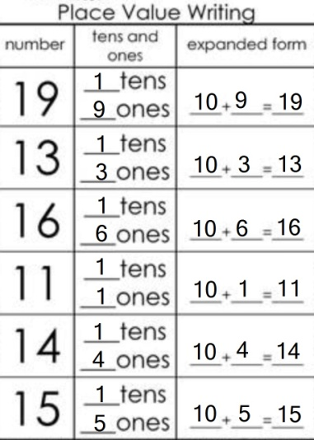

5.
30, 29, 28, 27, 26, 25, 24, 23, 22,21,20,19,18,17,16,15,14,13,12,11,10, 9,8,7,6,5,4,3,2,1.

6. 2,4,7,9,12,14,17,19,22,24,27,29.

