12th SAMPLE ASSIGNMENT
STD : PREP SUB : E.V.S DATE : 06.07.2020

1. Give two examples :
- Gents wear ___________ __________
- Ladies wear ___________ __________
- Summer clothes ___________ __________
- Winter clothes ___________ __________
2. Write answer in one word :
- Your mother wear this at home. __________
- We use to wear it in rainy season . __________
- Children wear it at night . __________
- People wear it in winter . __________
3. Fill up the blanks :
- We wear clothes to _________ our body .
- _________ is a gents wear .
- _________ is a ladies wear .
- We should always wear _______ clothes .

4.See the pictures and fill in missing letters :
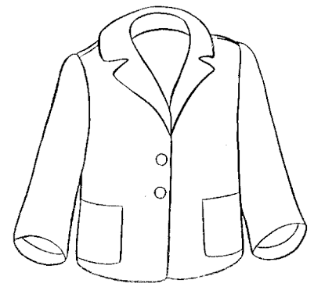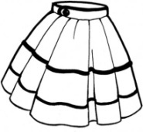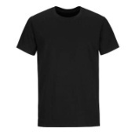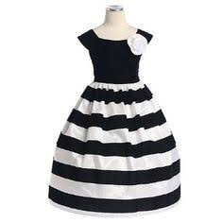

C ____ ____ T S ___ I ___ T T- SH ___ RT FR ___ C __
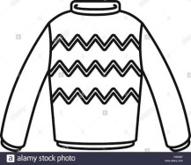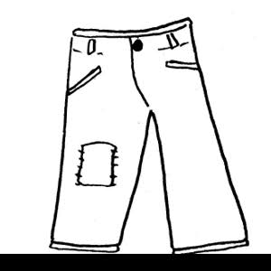

SW ___ ____ TER J ___ ANS

5.Read the instructions given in the bubble and colour accordingly :
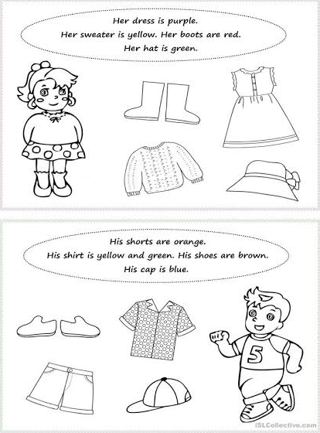

6. Complete page no. 29 , 30 , 31 in book .

ANSWER
1. a) shirt , trouser b) saree , frock c) T-shirt , shorts d) sweater , muffler
2. a) saree b) raincoat c) night dress d) sweater
3. a) cover b) Kurta c) Skirt d) clean
4. COAT , SKIRT , T- SHIRT , FROCK , SWEATER , JEANS

