SPECIAL ASSIGNMENT (12)-2020-21
CLASS- 1 SUBJECT- ENGLISH
WORKSHEET 4 DATE – 06/07/2020

Note- Do the following work in the English Grammar book and learn.

- Complete these sentences with the correct words from the box:

I | you | we

- Rosy and I are best friends. We walk to school every day.
- Heena, I am waiting for you. Hurry up!
- Robin, can you please come with me to the market?
- Biju says, “ I have hurt my knee. I cannot run.”
- My brother and I go to the park every evening. We like to play in the sand-pit.
- My name is Ritu. I am a nurse.

- Look at these pictures. Now, complete these sentences with the correct words from the box:

you are | I am | we are

- I am very tired. I am going to sleep. 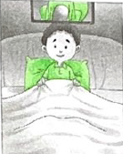
- Ms Sharma says, “Suraj, you are in the football team. 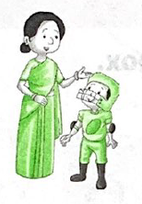
- Rai says, “Mother, I am so happy to see you.” 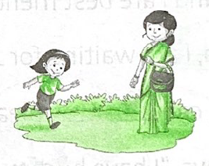
- Tejas, please come with me. You are in my class. 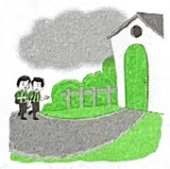

- My mother is taking Rana and me to the circus. We are going in the evening.

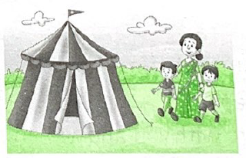
- Ms Lal says, “Thank you, Jim. You are very kind.” 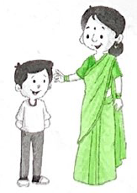

- Look at the pictures. Match the words to the correct pictures:

- plant the seed 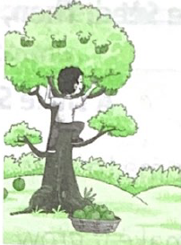 4.
- water the plant 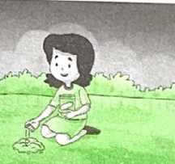 1.
- pluck a flower 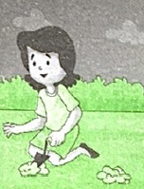 5.
- pick the fruit 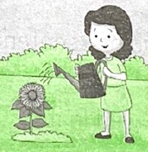 2.
- dig the soil 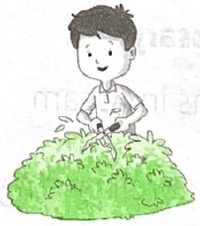 6.
- cut the grass 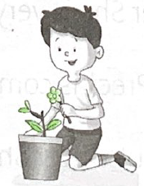 3.

We put a full stop (.) at the end of a sentence.

- Put full stops wherever necessary:

- I am visiting my cousins in Assam.
- It may rain. Take the umbrella with you.
- She is our science teacher. She is very kind.
- I’m going to the market. Preet is coming with me.
- Tina loves to drink coconut water. She drinks it every day.

- Look at these pictures. Then, complete these sentences with the help of the words in colour:

- 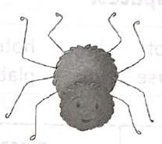
spider/big/head
  - This is a spider.
  - It has a big head.

- 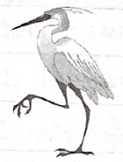
stork/long/beak
  - This is a stork.
  - It has a long beak.

- 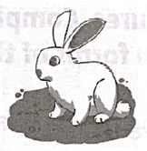
rabbit/bushy/tail
  - This is a rabbit.
  - It has a bushy tail.

- 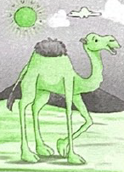
camel/big/hump
  - This is a camel.
  - It has a big hump.

- 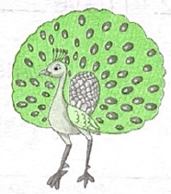
peacock/beautiful/tail
  - This is a peacock.
  - It has a beautiful tail.
WORKSHEET 5
Use of “This”, “That”, “These”, “Those”:
- “This” talks about one thing that is near us.
For example- This book is new.
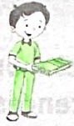
- “That” talks about one thing that is far from us.
For example- That bird is an owl.
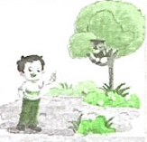

- “These” talks about things that are near us.
For example- These pencils are in the box.
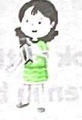

- “Those” talks about things that are far from us.
For example- Those kites are flying high.
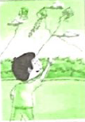

- Looks at these pictures. Match the words in A with the correct words in B to make complete sentences:

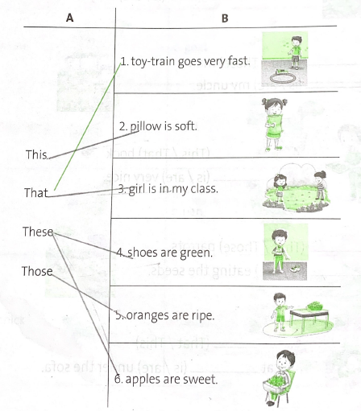
- We use “is” with “this/that”
- We use “are” with “these/those”

- Look at these pictures. Choose the correct words from the words given in brackets to complete these sentences:

- 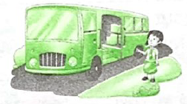
That (This/That) bus is (is/are) my school-bus.

- 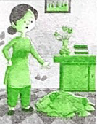
Those (That/Those) clothes are (is/are) dirty.

- 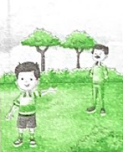
That (That/Those) man is (is/are) my uncle.

- 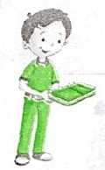
This (This/That) book is (is/are) very nice.

- 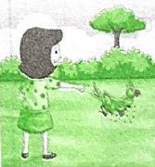
Those (That/Those) parrots are (is/are) eating the seeds.

- 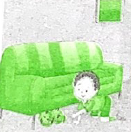
This (That/This) cat is (is/are) under the sofa.

- Look at these pictures. Match the baby animals to the correct big animals:

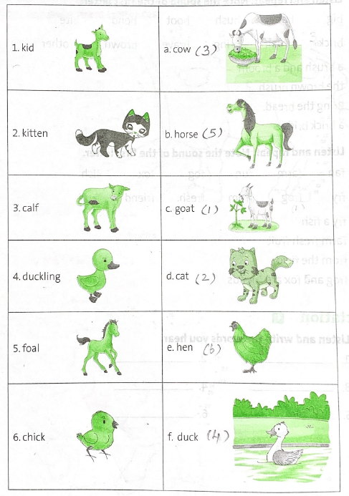

Home Assignment: Do Page number 31 – Question: H in the Grammar book.
Do Page number 27 to 32 in the Gulmohar course book.

******************

