SAMPLE ASSIGNMENT
SESSION: 2020 – 21

STD : PREP SUBJECT : English Date : 06.07.2020

- Fill in the blanks with “That” or ”This”.

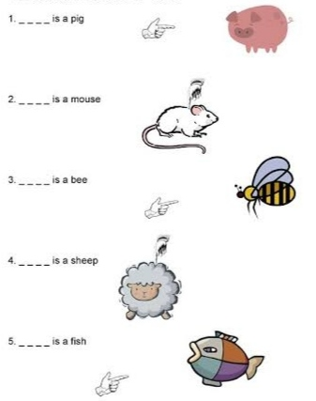

- Make sentences using “this” or “that”.

- ___________________________________________________ .
- 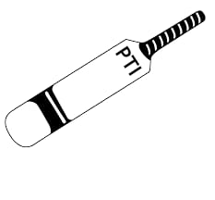 ___________________________________________________ .
- 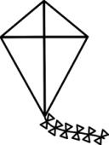 ___________________________________________________ .
- 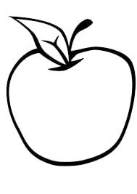 ___________________________________________________ .

- Colour the star that corresponds with the picture.
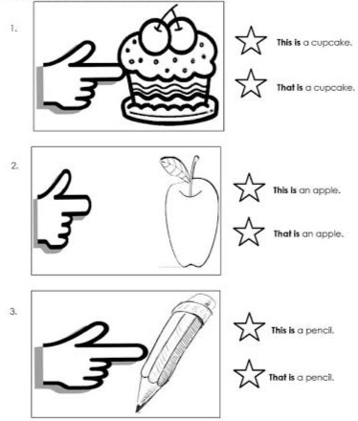

- Answer the following questions.

- 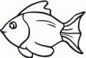 What is this ?
_____________________________

- What is that ?
_____________________________

- 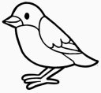 What is this ?
_____________________________

- What is that ? 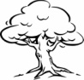
_____________________________

ANSWER KEY
- a) That b) This c) That d) This e) That

- a) This is a book. b) That is a bat. c) This is a kite. d) That is an apple.

- a) This is a fish. b) That is a book. c) This is a bird. d) That is a tree.

_____________________

