Special Assignment - 9

Class: I Subject: Computer Oral
Date: 6.07.20 – 10.07.20

Lesson 4: Uses of computer
- Introduction
- A computer is a wonderful and useful machine It can be used to write letters, send messages, play games, design cartoon & do sums.
- We can use computer to draw pictures in paint.
- We can use computer to type letters and do office jobs.
- We can use computer for numerical calculations.
- We can use computer for playing games, listening to music, watching movies or learning new things from the internet.

- Match the following by drawing lines.

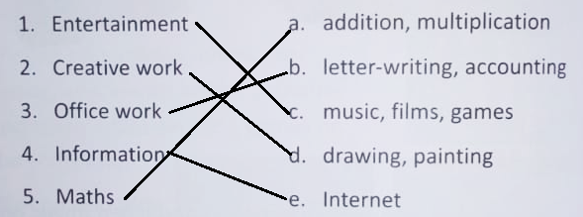

- Answer the following questions.

- What are the different uses of a Computer?
Ans- A computer can be used to send messages, play games, listen to music, do the sums etc.
- Name any two ways you can get entertainment by using a computer?
Ans- Playing video games and listening to music.

- What can we do using a computer?
Ans- We can learn many new things using internet on a computer.
- What are some of the office works we can do using a computer?
Ans- We can to type letters, make presentations etc., using a computer.

- Tell four lines about your favourite activities using a computer.

